Onouwkue Assent

1. uname -a: 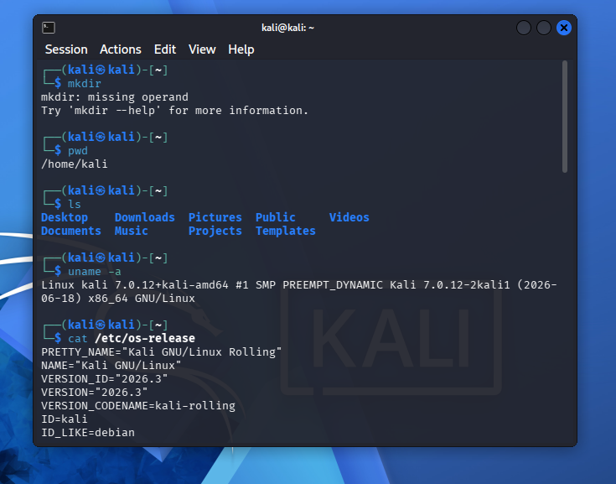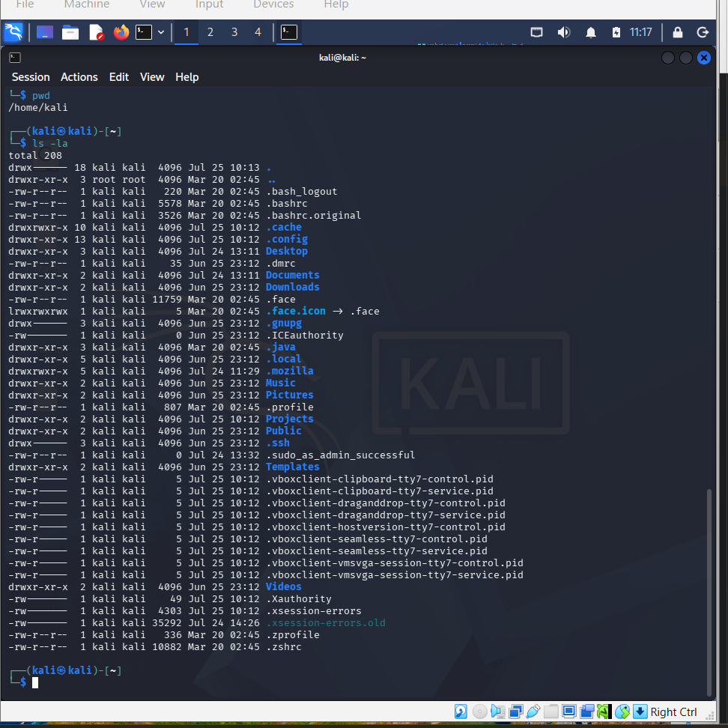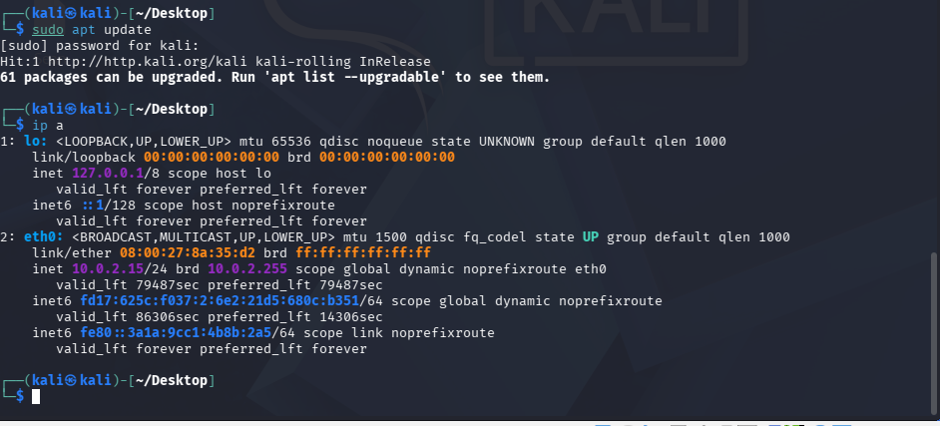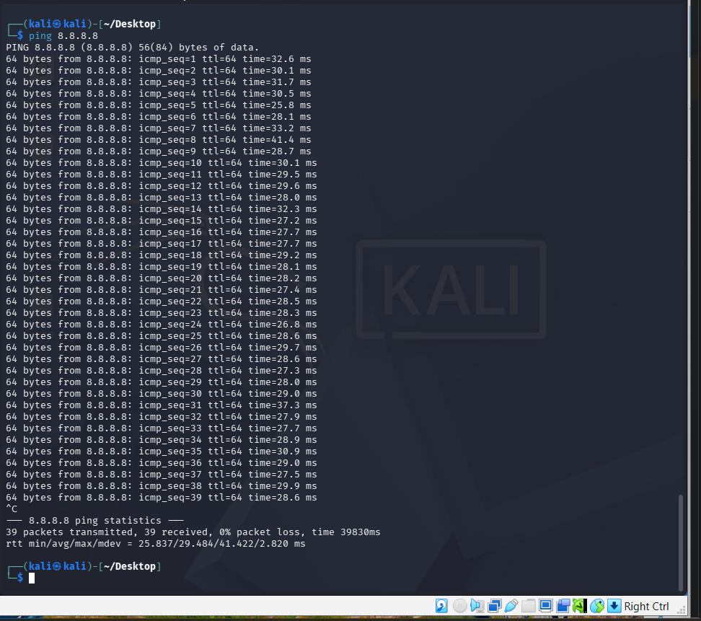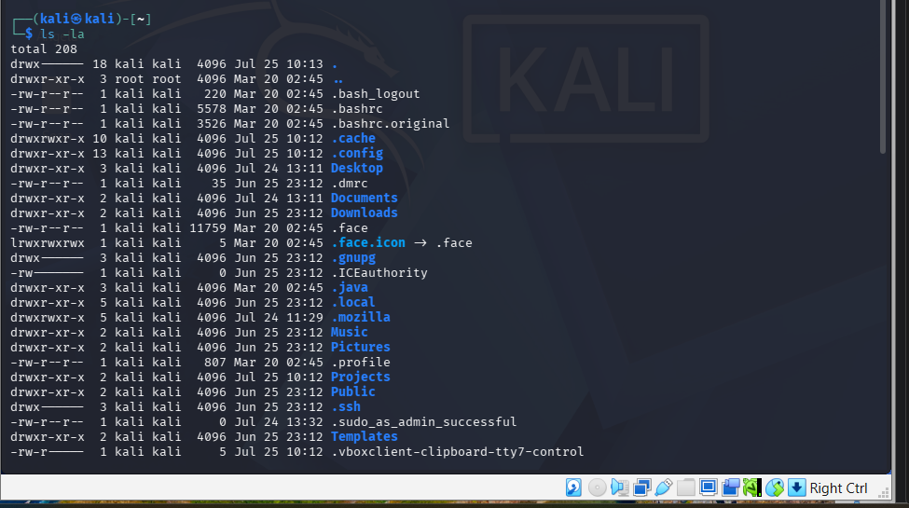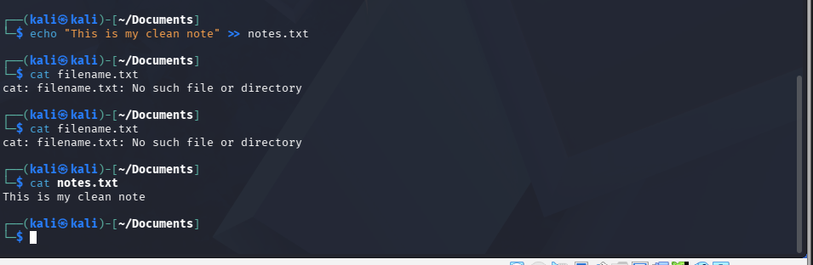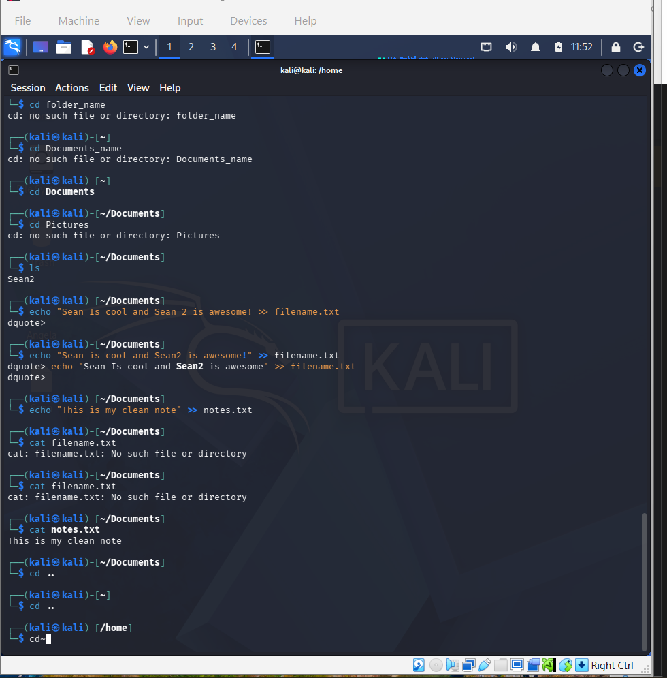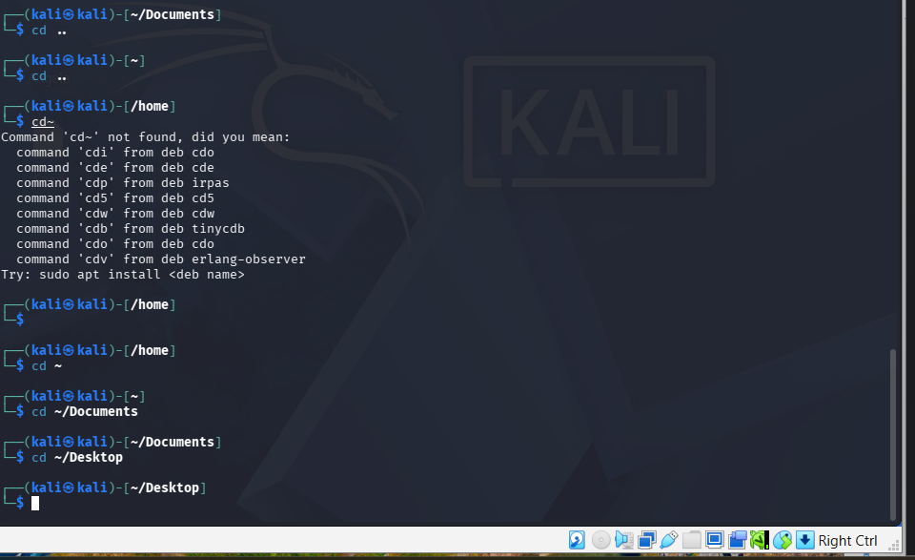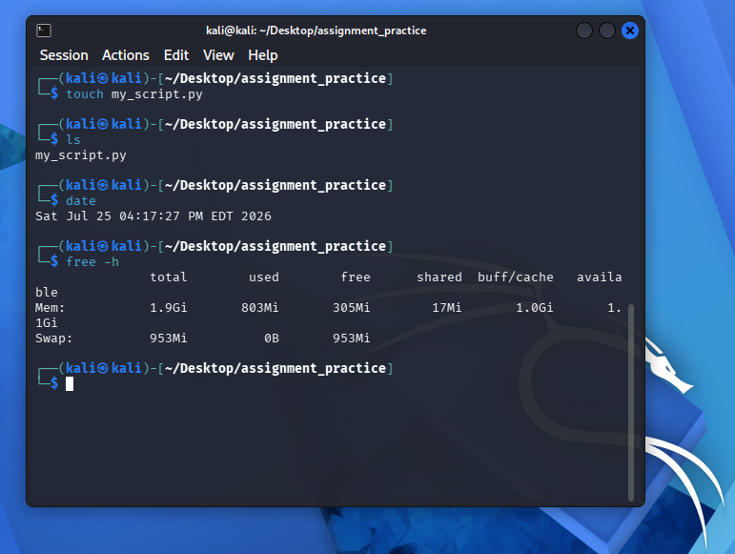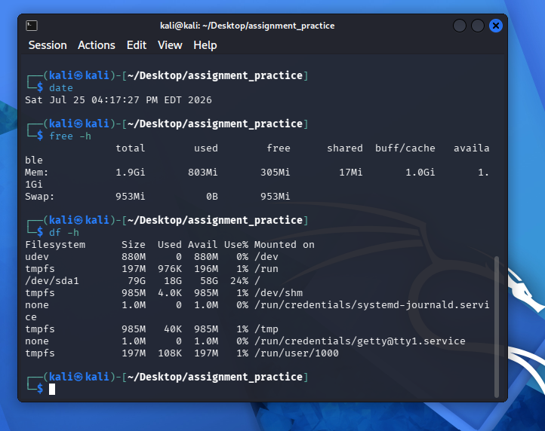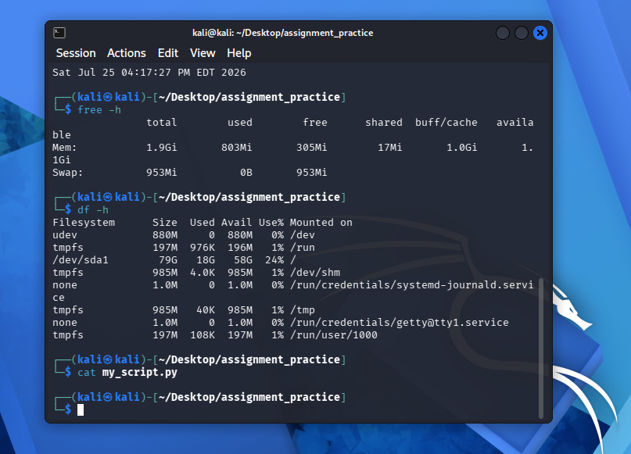This inputs the kernel release name and the system architecture

2. cat /etc/os-release; This input looks for the exact kali release version like Pretty Name, Name, and Version

3. ls -la: Looks at every single file and folder, the contents inside of it including hidden files without typing

4. nano: Is a terminal text editor

5: CTRL+O Enter: Allows text to be written in the nano terminal.

6: PWD: I am managing files in a folder which starts with PWD (print working directory)

7. echo and >>: echo is used to type text, and I used the append quote to type the file. and > a single arrow erases the file.

8. cat filename.txt: Used to check the file to see if it’s correct

9. cd ~: This symbol will take me back to the home directory

10. cd~/Documents: Goes back to the Documents

11. cd~/Desktop: Goes back to desktop

12. sudo apt update: sudo is the admin and apt is the manager. Once I type this prompt, I have to enter the pw kali

13. ip a: When I type in this command prompt, I see a inet which shows the IP address

14. ping 8.8.8.8: To test to see if I have internet and ctrl c to stop. Also ping google.com

15.traceroute: A network troubleshooting command that traces packets from the beginning point to its destination. Traceroute measures the response time it took to get to one destination another. If there is network failure, network analysts will be able to spot it.

16. touch: Allows me to start over and type a new command

17. date: Shows the date and time on the pc

18. free -h: shows how much ram is on the kali system.

19. df -h: shows how much storage is on the kali.

20. cat my_script.py: Prints entire file in the terminal

